* MODULE : 1 ( SDLC)

**Q.1 What is software? What is software engineering?**

Ans

🡪 the things or program that we can not touch physically is called software e.g., notepad, VLC media…etc

🡪software engineering is the branch of computer science that deals with design, development, testing, and maintenance of software applications.

**Q. 2 Explain types of software**:-

Ans

🡪1. Application Software:- MS office, Paint, etc…

2. system software:- notepad, calculator, etc…

3.Driver software:- Audio driver, video driver

4.Middleware:- Database middleware, server middleware

5.Programming software:- dev c++, VS code, Turbo c, eclipse, clion…

**Q.3 What is SDLC? Explain each phase of SDLC**

Ans

🡪SDLC = Software Development Life Cycle

* There are 6 phases of SDLC

1.Requirement Gathering – to gather all requirements

2.Analysis – analysis of all the requirements

3.Desingning – frontend part (HTML,CSS,JS, React js… etc)

4.Coding or Implementation – backend part ( JAVA ,PHP, .net)

5.Testing – to test the website or software

6.Maintainence – to maintain the website or software…

**Q.4 What is DFD? Create a DFD diagram on Flipkart**

Ans

🡪It is a way to representing the data in a flow

🡪Flipkart DFD diagram

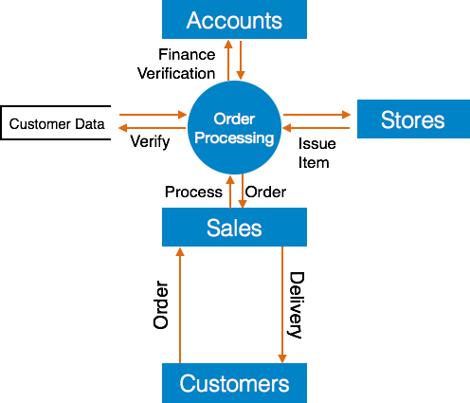

**Q.5 What is Flow chart? Create a flowchart to make addition of two numbers**.

Ans

* By using flowchart we can understand the flow of our coder program.

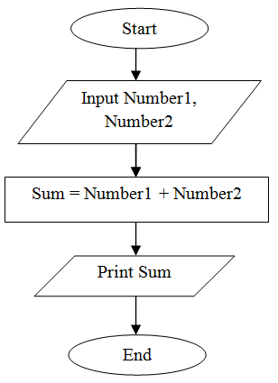

Q.6 **What is use case Diagram? Create a use-case on bill payment on paytm.**

Ans

🡪 Use-case diagrams describe the high-level functions and scope of a system.

**🡪**

